**Task7- AWS-3**

Create a S3 bucket, with no public access and upload files to the bucket & view the logs using CloudWatch for the uploaded files.

Login to AWS portal🡪 Open S3🡪Create Bucket

Select the bucket type 🡪 General Purpose🡪 and enter the Bucket name🡪 Object Ownership 🡪 ACL disable(as per task)🡪Block all public access🡪 leave the recommended🡪 create bucket.

Once S3 bucket created🡪 upload🡪add files.

Once Bucket created, Now add the cloudwatch to monitor logging information.

2. Launch two ec2-instances and connect it to a application load balancer, where the output traffic from the server must be an load balancer IP address.Goto🡪Create e2 instance🡪Give a name 🡪select the OS Ver🡪Instance type🡪Key Pair🡪Networking🡪Edit🡪Select the VPC 🡪 subnet🡪Launch Instance.

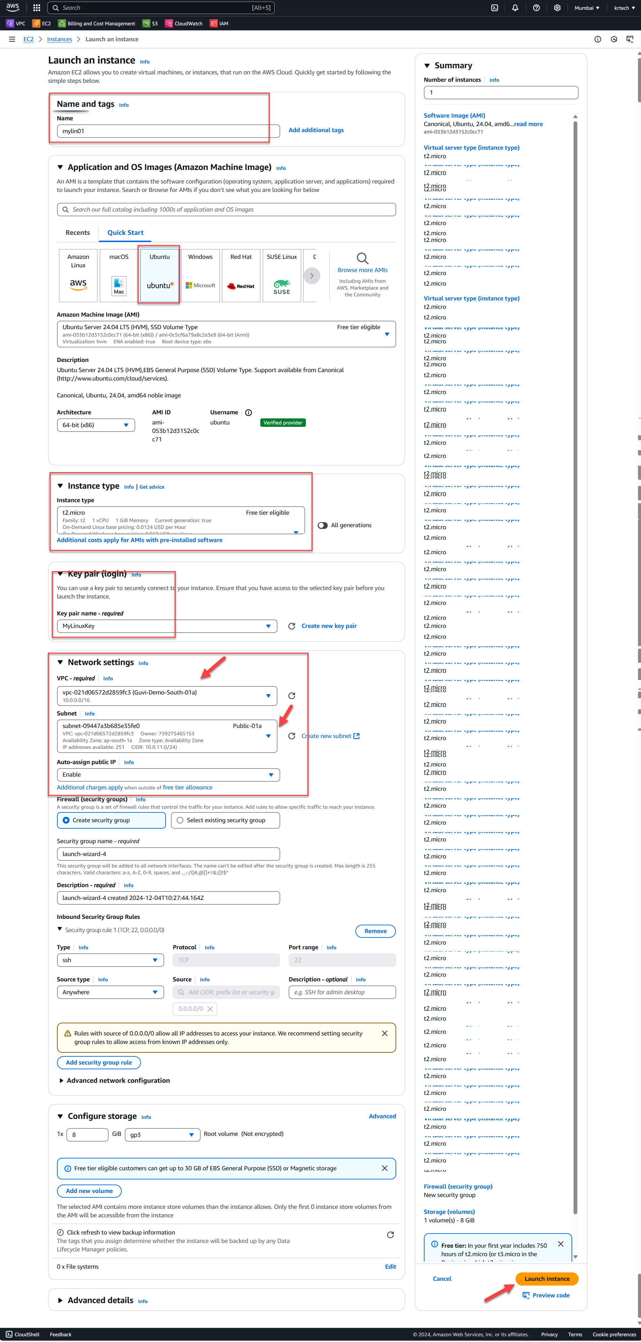

Repeat it for second VM as well.

Two instance has been created and Default apache site reachable.

Configure the VM with Apache server for load balancer test.

VM 1

Repeat the same for VM2 as well.

Now Configure the load balancer.

First we need to create a target group.

Create another Target group and repeat the same steps.

Now create the Load Balancer

Once Application Load Balancer created🡪 Goto Listeners and rules🡪 edit the HTTP:80🡪

Once ALB created please update the DNS address in Both Instance config file

Now us the DNS name in web browser and see the Load balancer works

DNS:

DNS with /app

DNS with /webapp

